MEDIA ADVISORY
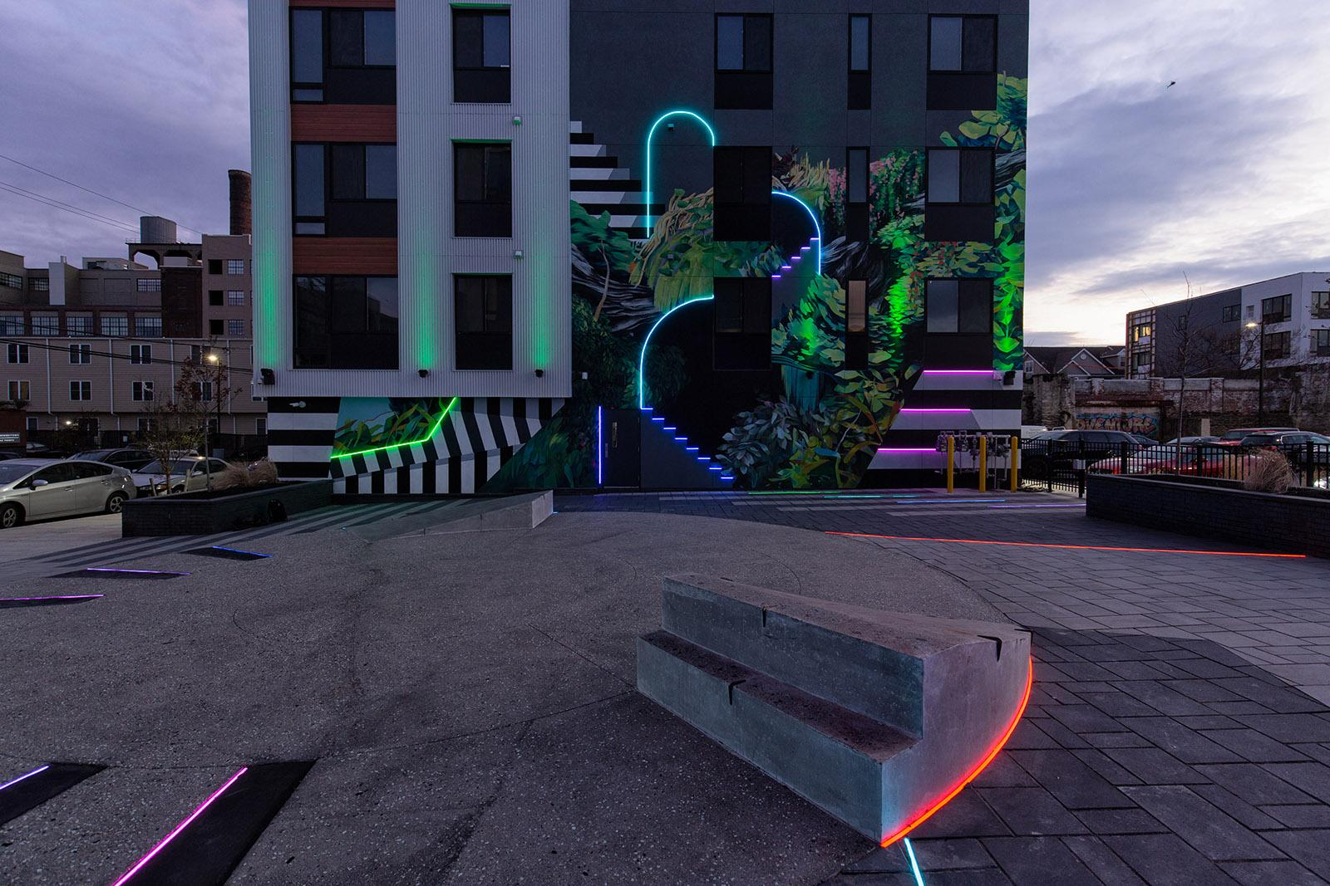
Mural Arts Philadelphia Celebrates Future Valley Plaza: a New, Immersive, Augmented Reality Plaza in Brewerytown
Kick-Off Event Celebrates the Debut of First of Its Kind Public Art

WHAT: Mural Arts Philadelphia will host a kick-off event celebrating Future Valley Plaza–
an immersive public art installation created by renowned Philadelphia artists David Guinn and Robert Goodman, with Augmented Reality leader Brian Yetzer.

Future Valley Plaza is the first public space of its kind in Philadelphia. The artwork transforms the space between two recently constructed apartment buildings into an immersive experience of color, light, and augmented reality. An Innovative LED product- flexi neon- is woven into richly painted murals on either side of the plaza as well as into the ground surface of patterned pavers and sculptural structures.

In Brewerytown, a neighborhood amid great change, Future Valley Plaza asks: Where have we been, and where are we going?

Augmented Reality creates a dramatic virtual environment where the past and future of the site merge. This AR experience, available for free via phone and tablet app, synthesizes imagined structures, historical imagery, text, and audio to educate and inspire visitors.

WHEN: Saturday, December 10, 2022, 4-6 PM
Ceremony at 4:37 PM, sunset with:
- Artists: David Guinn, Robert Goodman, Brian Yetzer
- Jane Golden, Executive Director, Mural Arts Philadelphia
- Representative of the Philadelphia Redevelopment Authority
- Civic Association representatives
- Brewerytown neighbors and business owners

WHERE: 1410 N 31st Street
Philadelphia, PA
*NOTE: Just North of the intersection of 31st and Master Streets Future Valley

WHY: This launch event celebrates the power of art to transform Public Space through beautification and education. The project is created in partnership with Mural Arts Philadelphia and the Philadelphia Redevelopment Authority. Westrum Development generously funds the project through the City of Philadelphia’s Percent for Art Program. The Plaza sits on the former site of a 19th-century brewery. It pays homage to the past while gesturing toward the future.

About Mural Arts Philadelphia:
Mural Arts Philadelphia is the nation's largest public art program, dedicated to the belief that art ignites change. For more than 35 years, Mural Arts has united artists and communities through a collaborative and equitable process, creating over 4,000 artworks that have transformed public spaces and individual lives. Mural Arts aims to empower people, stimulate dialogue, and build bridges to understanding with projects that attract artists from Philadelphia and around the world and programs that focus on youth education, restorative justice, mental health and wellness, and public art and its preservation. Popular mural tours offer a firsthand glimpse into the inspiring stories behind Mural Arts' iconic and unparalleled collection, which has earned Philadelphia worldwide recognition as the "Mural Capital of the World." For more information, call 215-685-0750 or visit muralarts.org. Follow along on social media: @muralarts on Twitter and Instagram, @MuralArtsPhiladelphia on Facebook, and phillymuralarts on YouTube.
###

Media contacts:
Kaitlyn Haney, Signature 57
khaney@signature57.com
215.514.6495

Sinead Murray, Signature 57
smurray@signature57.com
215.584.7730

Future Valley Plaza, Looking South

Future Valley Plaza, Looking North
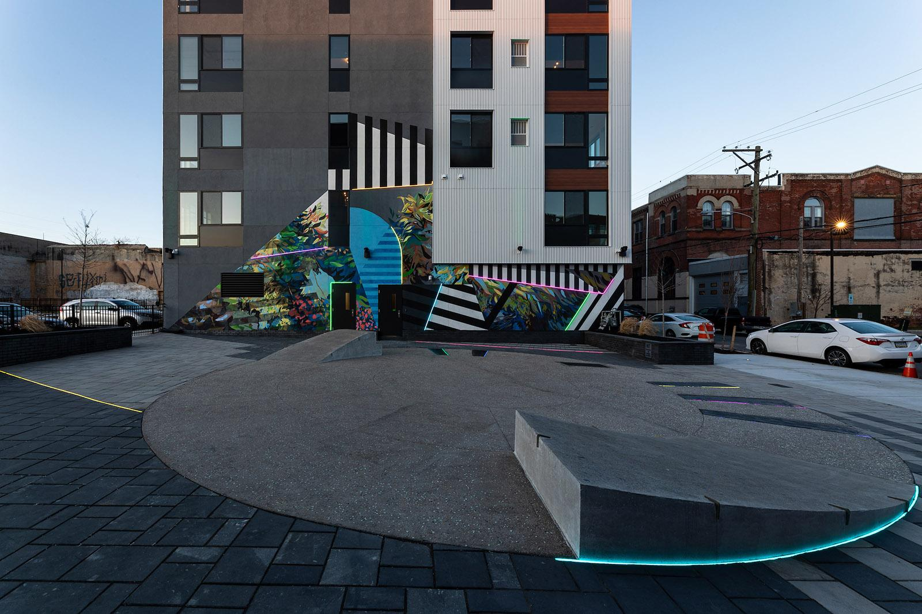
Future Valley Plaza at night:
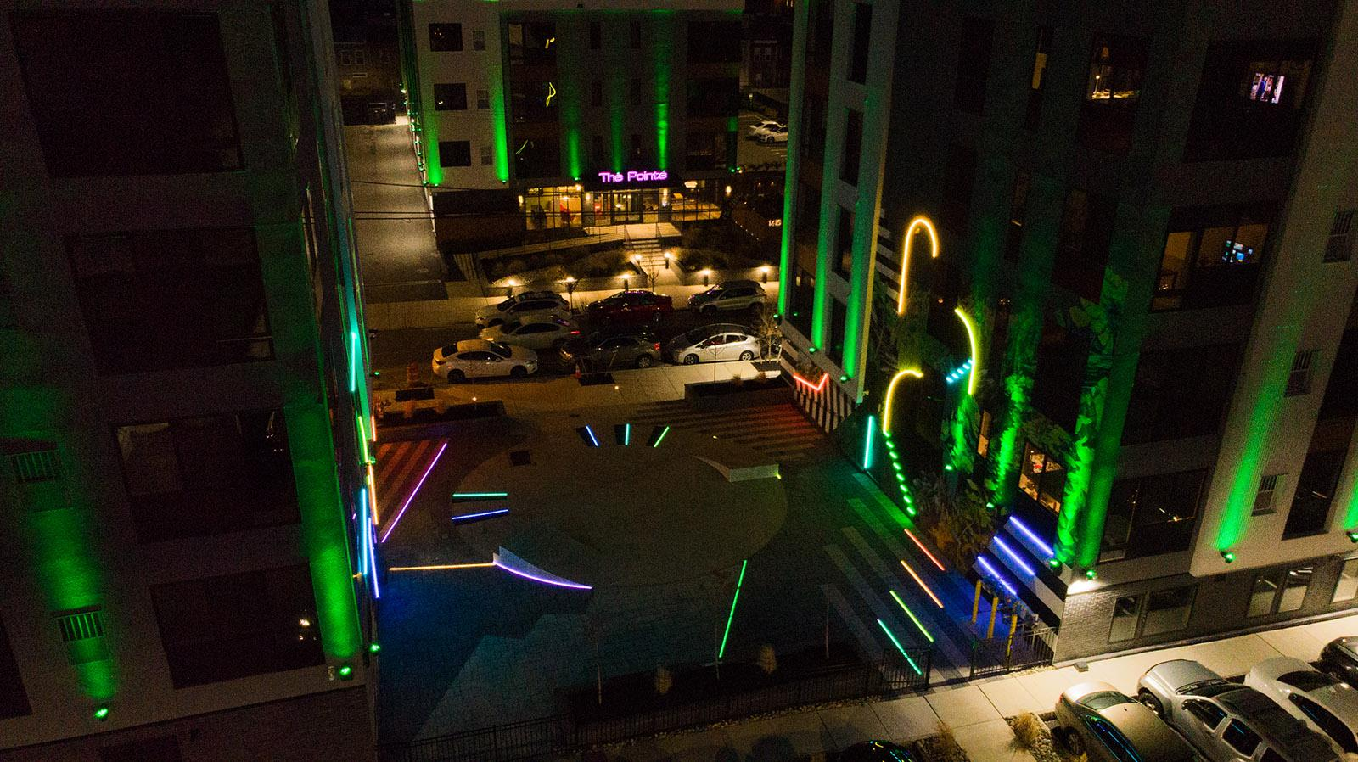

Augmented Reality Experience screenshot
